Hemel Hempstead Cycling Club
Open 25 Mile Time Trial
Start Sheet for the
Paul Bennett Memorial

Sunday 23rd June 2019

Promoted for and on behalf of Cycling Time Trials under their Rules and Regulations

Event Secretary:  John Lacey  Woodlands, Water End Road,  Potten End, Berkhamsted,  HP4 2SG  01442 871953  07920 104056  johnlacey@btinternet.com  Organiser on the day:  John Lacey 07920 104056 |  | Time Keeper:  Annette Lacey (Hemel Hempstead CC)  Headquarters:  Launton Parish Hall  Bicester Road  Launton, Oxon  OX26 5DP  (The HQ is approx 2 miles from start – see map below please allow enough time to reach the start and please familiarise yourself with the route)

Prizes: 1st £30 and Memorial Trophy (for one year) 2nd £20 3rd £10
Ladies 1st £30 2nd £20 3rd £10
Vets on Std 1st £20 2nd £15 3rd £10
Tandem 1st £20 2nd £10
Best team of 3 £10 each
Best rider 25 years old or under £50 donated by Paul Bennett’s family. One prize per rider except Team.

Course: F13/25
START in Launton Lane, off the A41, approximately 3 miles southeast of Bicester, at a point about 70 yards from the A41, some 30yards south of 'Give Way 100yards' sign, level with tree immediately before gated entrance.
Proceed to junction with A41, where turn left and continue along A41, through Kingswood past new RAB at Woodham, through Waddesdon (Warning: two sets of pedestrian controlled lights!), to:-
TURN at RAB at Aylesbury Vale Parkway station, retrace outward route through Waddesdon (Warning: two sets of pedestrian controlled lights!), over Woodham RAB and Kingswood, past the end of Launton Lane, to turn left onto the B4011 (towards Thame) to:-
FINISH on the B4011, 2 miles from junction with A41.
You must sign on in advance of your start at the headquarters where you can pick up your number and receive any last minute instructions or warnings. Please sign your number back in after your ride in exchange for a free drink.
Please keep your head up at all times. At the roundabouts the traffic coming from the right has priority over you, so please give way.
Local Regulation No. 1 - No U turns should be made in sight of the start or finish areas while riding on the public highway.
Local Regulation No. 2 - Competitors, their helpers and event officials must use the toilet facilities provided at event headquarters as required. Fields and hedgerows must NOT be used for toilet purposes. Failure to observe this regulation may result in disciplinary action against those concerned.
Local Regulation No. 3 - No cars other than that of the timekeeper(s) and other event officials are to be parked in the vicinity of the start or finish points.
Further to Local Reg 3 it should be noted there is no parking available near to the start for those that like to warm up nearby. Please use the HQ.
Safety – not your performance – is your first priority
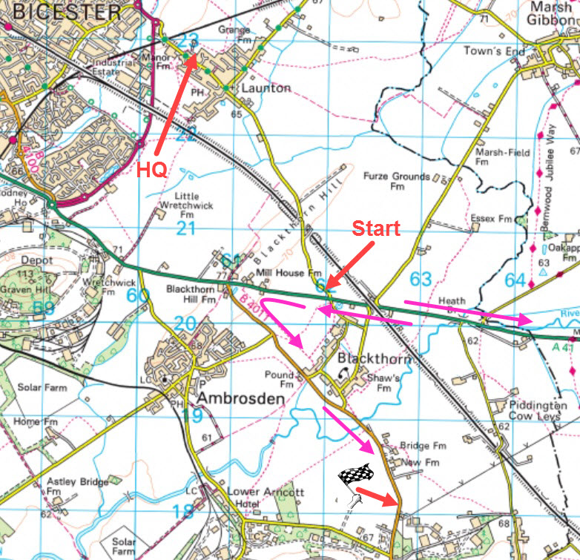

As this is the parish hall, the church is almost right opposite, and there will be a busy service going on at the time of the event, so please do NOT park in front of the hall in the road. There is plenty of parking to the rear and further around the rear access road to the sports field.

Returning to the HQ from the finish: 2 ways:
Return back to the A41along the B4011 to the junction and either
A: turn left towards Bicester and then right at the RAB and then right into Launton, or
B: turn right towards Aylesbury then left past the start and back to Launton.

Important note: There are two sets of pedestrian controlled traffic lights in Waddesdon. We will have a marshal there to help assist users of the lights, but their primary job is to ensure that riders comply with traffic regulations and do stop if they turn red. Anyone reported for going through the red lights WILL BE disqualified and reported to the district for disciplinary action – which could be a suspension. Just to make matters worse, one set of lights are directly outside the local police station.
An observer will be in attendance to see that all riders comply with CTT regulations with regards to bike equipment and riding conduct. Please ensure you are fully compliant and conversant with the current CTT regulations (in particular those regarding front wheels and arm positions on tribars, etc.).
No event runs completely smoothly, and I will apologise in advance if anything does go wayward, but if you can think of any improvements, then please let me know.
We intend to have the result board projected up on a screen, so please bring your specs if you need them!
There will be a quick prize presentation at the end including the presentation of the memorial trophy by Paul Bennett’s daughter Pauline, so please stick around for that.
Results will be sent to the CTT website, and also will be available on our own club website here, hopefully within a few hours of the event finishing:

No. | Name | Club | Cat | Start
 | Tandem Event
17 | Richard May | Islington Cycling Club | V | 07:17
 | David Shannon | Islington Cycling Club | V
18 | Richard Moule | Bossard Whs | V | 07:18
 | Joanna Spragg | Bossard Whs | WV
19 | Brian Foran | Lampard RC | V | 07:19
 | Nikki Hunt | VTTA (London & Home Counties) | WV
 | Solo Event
20 | Chris Symonds | North Road CC | V | 07:20
21 | Graham Pepperdine | Verulam CC | V | 07:21
22 | Mark Glendinning | Cowley Road Condors CC | V | 07:22
23 | Peter Redshaw | CC London | V | 07:23
24 | Debbie Knott | Team Velovelocity | WV | 07:24
25 | Andy Court | Bicester Millennium CC | V | 07:25
26 | Andrew Bradley | Hemel Hempstead CC | V | 07:26
27 | Simon Powell | Redhill CC | V | 07:27
28 | Bruno Cabrelli | Hemel Hempstead CC | Juv | 07:28
29 | David Dyer | Cowley Road Condors CC | V | 07:29
30 | Luke Clarke | TMG Horizon Cycling Team | S | 07:30
31 | Derek Dowdeswell | Gloucester City Cycling Club | V | 07:31
32 | Trevor Hook | Team Milton Keynes | V | 07:32
33 | Tim Seddon | G.S. Henley | V | 07:33
34 | Mark Pankhurst | Hemel Hempstead CC | V | 07:34
35 | Tim Beaven | Bicester Millennium CC | V | 07:35
36 | Paul Sexton | CC Breckland | V | 07:36
37 | Lenka Vackova | Rapha Cycling Club | WS | 07:37
38 | Lindsay Scott | Northants Tri Club | WS | 07:38
39 | Michael Bannister | Chronos RT | V | 07:39
40 | Adam Robertson | University of Bath Cycling Club | Esp | 07:40
41 | Dave Johnson | VC 10 | V | 07:41
42 | Ian Markham | Chronos RT | V | 07:42
43 | Debbie Honour | VC 10 | WV | 07:43
44 | Samantha Messenger | Bicester Millennium CC | WV | 07:44
45 | Adam Fisher | Cambridge CC | S | 07:45
46 | Alan Crane | Chronos RT | V | 07:46
47 | Helen Reynolds | Hemel Hempstead CC | WV | 07:47
48 | Allison Kaye | Verulam CC | WV | 07:48
49 | Stephen Messenger | Bicester Millennium CC | V | 07:49
50 | George Clark | Catford CC | Esp | 07:50
51 | Nick Hickman | Team Salesengine.co.uk | V | 07:51
52 | Emily Robertson | NOPINZ | WS | 07:52
53 | Nick Mccormick | Epsom CC | V | 07:53
54 | James Moss | North Road CC | V | 07:54
55 | Sam Wightman | Chelmer CC | V | 07:55
56 | Toby Maloy | Team Signum | S | 07:56
57 | Lee Heron | Banbury Star Cyclists' Club | V | 07:57
58 | Richard Boley | Hemel Hempstead CC | V | 07:58
59 | Stan Nwaka | Verulam Really Moving | V | 07:59
60 | Peter Lawrence | High Wycombe CC | V | 08:00

